Machine Learning Prediction: Classification

In this hands-on lab, you explore the Azure Machine Learning prediction functionality by using the Prediction Experiment for Dynamics 365 Business Central model and algorithm. This algorithm allows you to predict the classification or regression, based on a model trained on your sample data.

Contents

Create a new workspace 3

Download demo data 3

Obtain a machine learning endpoint and API key 3

Create table and page for setup 7

Solution: Table 50130 Classification Setup.al 7

Solution: Page 50130 Classification Setup.al 8

Classification prediction: Sales volume 10

Sales Volume table 10

Solution: Table 50131 Sales Volume.al 10

Import Sales Volume XMLport 12

Solution: XmlPort 50131 Import Sales Volume.al 12

Classification Setup table and page modifications 12

Sales Volume Classif. Mgt. Codeunit 14

Solution: Sales Volume Classif. Mgt. 16

Sales Volume page 17

Solution: Page 50131 Sales Volume.al 17

Sales Volume Prediction Page 19

Solution: Page 50132 Sales Volume Prediction.al 20

Test Sales Volume prediction functionality 22

Challenge Yourself: Titanic Survival Prediction 26

Extend the setup 26

Create the data model 26

Solution: Table 50133 Titanic Passenger.al 27

Create the XmlPort 28

Solution: XmlPort 50133 Import Titanic Passengers.al 29

Create the codeunit stub 29

Create the list page 30

Solution: Page 50133 Titanic Passengers.al 30

Create the prediction page 31

Solution: Page 50134 Titanic Prediction.al 32

Final challenge: business logic 33

Solution: Codeunit 50133 Titanic Passenger Pred. Mgt.al 34

# Create a new workspace

Before you start, create and configure a new workspace (if you are not sure how, check the “Instructions for the beginners” document).

Use the name “Classification Demo” for the new workspace. Use range 50130 to 50135 for this extension.

# Download demo data

This hands-on lab requires you to have access to demo data that was prepared in advance. You can download the demo data from here:

<http://bit.ly/RedCarpetClassificationData>

There is one Excel file, and two CSV files. You will need these files to complete the exercises in this lab. The exercises will instruct you when and how to use these files.

# Obtain a machine learning endpoint and API key

In this exercise, you publish the prediction model as your own web service, and obtain an endpoint and API key to communicate with it form Business Central.

1. Open your browser and navigate to <https://gallery.azure.ai/Experiment/Prediction-Experiment-for-Dynamics-365-Business-Central>

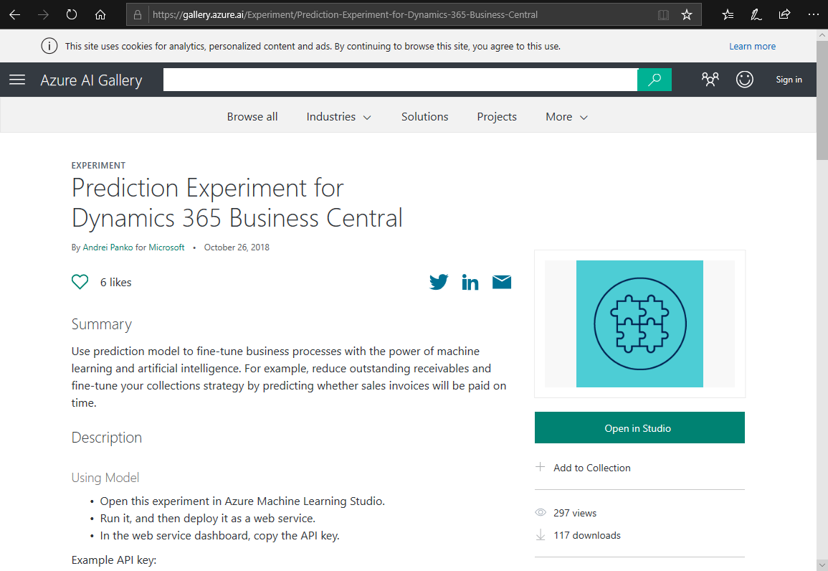

1. Click **Open in Studio**.
2. If asked for your account, sign in with your Microsoft or work account that has access to an Azure tenant. Otherwise, complete the sign up process, signing up for a free 7-day access.
3. When you sign in to Microsoft Azure Machine Learning Studio, you will be asked to copy the experiment from Gallery:

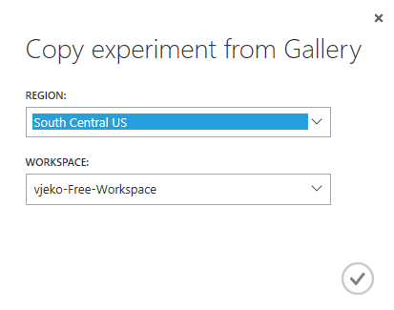

1. Accept the defaults by clicking the Ok button (with the checkmark).
2. After the Prediction Experiment for Dynamics 365 Business Central opens in the Machine Learning Studio, in the bottom bar click **Run**.



The experiment will start running and building its prediction model.

1. After the model finishes running, click **Deploy web service**.



1. Your prediction experiment is now deployed as web service, and you are presented with this page. Click Request/Response:

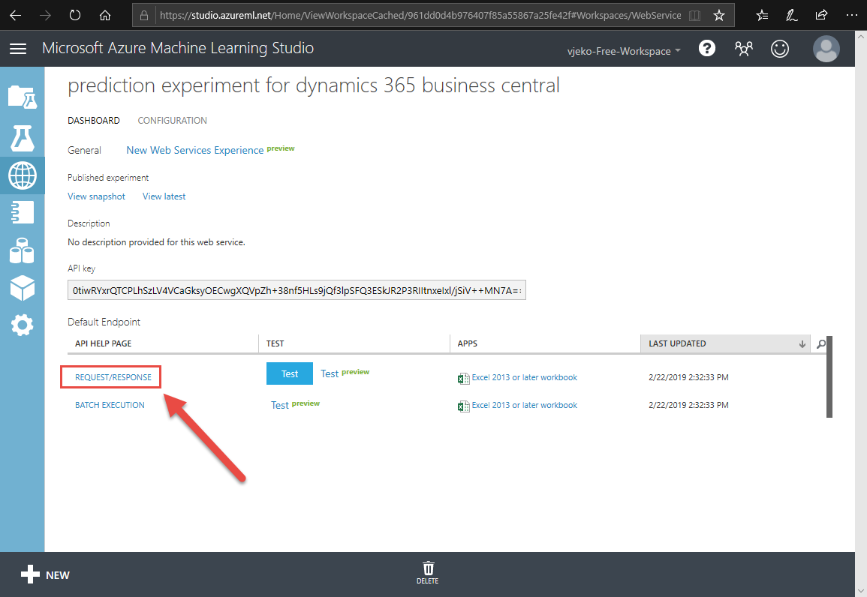

1. A new tab opens with the Request Response API Documentation. Select and copy the **Request URI**:

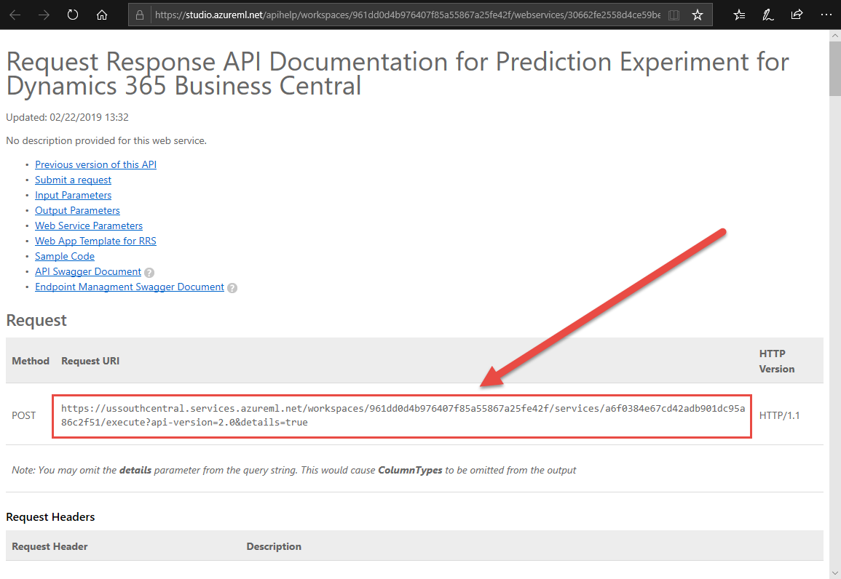

Store this URL in a safe place. This is your URL specific to this web service.

1. Go back to the **Web services** tab (in the browser, that is the tab where you clicked **Request/Response**), and select and copy the **API key**:

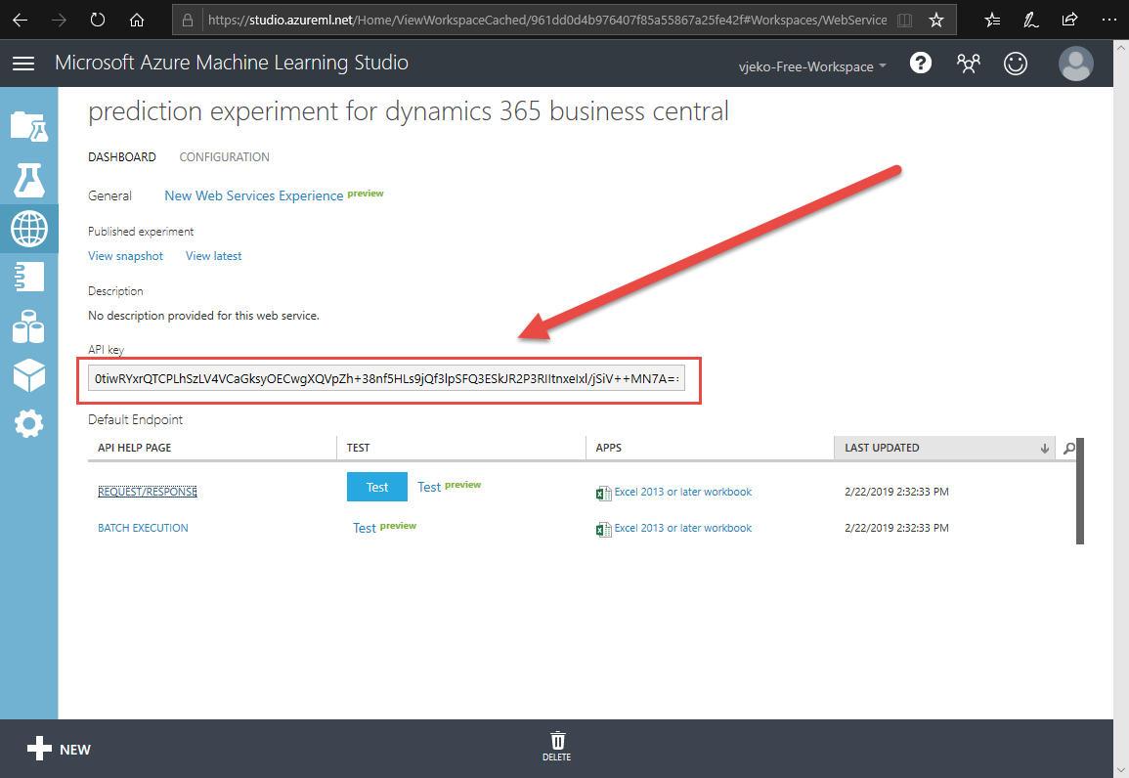

Store this key in a safe place. You will need this key whenever invoking your web service.

1. Close the browser.

# Create table and page for setup

In this exercise, you create a table and a page to hold the necessary extension configuration. Also, you create a page to allow users to modify this configuration.

1. Create a new table 50130 Classification Setup, with the following fields:

|  |  |  |
| --- | --- | --- |
| ID | Field | Type |
| 1 | Primary Key | Code[10] |
| 2 | API URI | Text[250] |
| 3 | API Key | Text[250] |

1. Make the **Primary Key** field non-editable.
2. Make the **Primary Key** field the primary key of the table.
3. Create a new page 50130 Classification Setup, with the following specification:
   1. It’s of card type.
   2. It uses table **Classification Setup** as its source.
   3. It does not allow deleting.
   4. It contains one FastTab named **General**, and in there it shows the **API URI** and **API Key** fields from the source table. Make these fields multi-line.
   5. Make the page available in the **Tell me** feature in the **Administration** usage category.
   6. When page is opened, if no record is found, create one.
4. Build, deploy, and run your extension.
5. In the **Tell me** box, search for and then run **Classification Setup**.
6. In the Classification Setup page, put your API URI and API Key that you obtained in the previous exercise, into the corresponding text boxes.

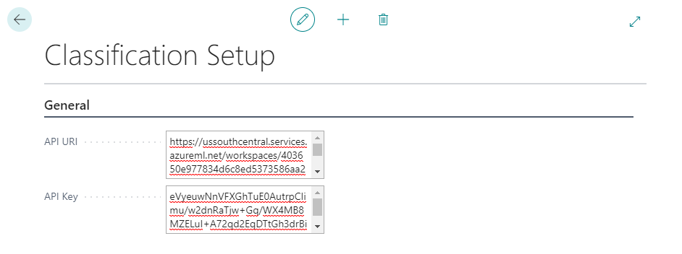

## Solution: Table 50130 Classification Setup.al

table 50130 "Classification Setup"

{

Caption = 'Classification Setup';

fields

{

field(1; "Primary Key"; Code[10])

{

Caption = 'Primary Key';

Editable = false;

}

field(2; "API URI"; Text[250])

{

Caption = 'API URI';

}

field(3; "API Key"; Text[250])

{

Caption = 'API Key';

}

}

}

## Solution: Page 50130 Classification Setup.al

page 50130 "Classification Setup"

{

Caption = 'Classification Setup';

PageType = Card;

SourceTable = "Classification Setup";

DeleteAllowed = false;

UsageCategory = Administration;

ApplicationArea = All;

layout

{

area(Content)

{

group(General)

{

Caption = 'General';

field("API URI"; "API URI")

{

MultiLine = true;

ApplicationArea = All;

}

field("API Key"; "API Key")

{

MultiLine = true;

ApplicationArea = All;

}

}

}

}

trigger OnOpenPage();

begin

if not Get() then begin

Init();

Insert();

end;

end;

}

# Classification prediction: Sales volume

In this exercise, you’ll create a table to contain your sales volume data. You’ll build a user interface that will allow you to view and modify the data, as well as an XMLport object to import the demo data into the table. Also, you’ll extend the setup table you created in the previous exercise with an additional blob field to store the sales volume prediction model.

Then, you’ll build a codeunit that will prepare a model based on the sales volume data, store that model in the setup table, and then use that model to invoke the prediction web service. To help you with this, you’ll use the standard codeunit 2003 ML Prediction Management.

Finally, you’ll create a page that will allow you to enter all the data except the Volume field. From this page you’ll allow invoking the prediction model that will predict **Volume** for all the records in the page.

## Sales Volume table

1. Create a new table 50131 Sales Volume with the following fields:

|  |  |  |
| --- | --- | --- |
| ID | Field | Type |
| 1 | Entry No. | Integer  Set the AutoIncrement property. |
| 2 | Item No. | Code[20] |
| 3 | Posting Date | Date |
| 4 | Volume | Option:  None, VeryLow, Low, Medium, High, VeryHigh, Extraordinary |
| 5 | Color | Option:  Red, Green, Blue |
| 6 | Size | Option:  S, M, L, XL |
| 7 | Price | Decimal |
| 8 | Confidence | Decimal |

1. Make the **Entry No.** field the primary key of the table.

### Solution: Table 50131 Sales Volume.al

table 50131 "Sales Volume"

{

Caption = 'Sales Volume';

fields

{

field(1; "Entry No."; Integer)

{

Caption = 'Entry No.';

AutoIncrement = true;

}

field(2; "Item No."; Code[20])

{

Caption = 'Item No.';

TableRelation = Item;

}

field(3; "Posting Date"; Date)

{

Caption = 'Posting Date';

}

field(4; Volume; Option)

{

Caption = 'Volume';

OptionMembers = None,VeryLow,Low,Medium,High,VeryHigh,Extraordinary;

OptionCaption = 'None,VeryLow,Low,Medium,High,VeryHigh,Extraordinary';

}

field(5; Color; Option)

{

Caption = 'Color';

OptionMembers = Red,Green,Blue;

OptionCaption = 'Red,Green,Blue';

}

field(6; Size; Option)

{

Caption = 'Size';

OptionMembers = S,M,L,XL;

OptionCaption = 'S,M,L,XL';

}

field(7; Price; Decimal)

{

Caption = 'Price';

}

field(8; Confidence; Decimal)

{

Caption = 'Confidence';

}

}

keys

{

key(Primary; "Entry No.") { }

}

}

## Import Sales Volume XMLport

1. Create a new XMLport 50131 Import Sales Volume with the following specification:
   1. It uses VariableText format.
   2. It uses “;” as its field separator.
   3. It supports only import direction.
   4. It contains schema with one root text element, that contains one table element that will contain fields from the Sales Volume table: Item No., Posting Date, Volume, Color, Size, and Price.

### Solution: XmlPort 50131 Import Sales Volume.al

xmlport 50131 "Import Sales Volume"

{

Format = VariableText;

FieldSeparator = ';';

Direction = Import;

schema

{

textelement(root)

{

tableelement(Volume; "Sales Volume")

{

fieldelement(Price; Volume."Item No.") { }

fieldelement(Gender; Volume."Posting Date") { }

fieldelement(Material; Volume.Volume) { }

fieldelement(SleeveLength; Volume.Color) { }

fieldelement(IsChristmas; Volume.Size) { }

fieldelement(DecemberSales; Volume.Price) { }

}

}

}

}

## Classification Setup table and page modifications

1. Open Table 50130 Classification Setup.al
2. Define the following new field:

|  |  |  |
| --- | --- | --- |
| ID | Field | Type |
| 4 | Sales Volume Model | Blob |
| 5 | Sales Volume Model Quality | Decimal  The field must not be editable |

Hint: it’s the following new code:

field(4; "Sales Volume Model"; Blob)

{

Caption = 'Sales Volume Model';

}

field(5; "Sales Volume Model Quality"; Decimal)

{

Caption = 'Sales Volume Model Quality';

Editable = false;

}

1. Define a global function **GetModel** that reads the model stored in the Sales Volume Model blob field and returns it as text as function’s return value. The function uses the standard codeunit **Type Helper** to convert from blob to text.  
     
   Hint: it’s the following new code:

procedure GetModel(): Text

var

TypeHelper: Codeunit "Type Helper";

BlobRef: FieldRef;

RecRef: RecordRef;

begin

RecRef.GetTable(Rec);

BlobRef := RecRef.Field(FieldNo("Sales Volume Model"));

exit(TypeHelper.ReadBlob(BlobRef));

end;

1. Define a global function **SetModel** that receives one text parameter that represents the model to be stored in the **Sales Volume Model** field. Inside this function write code that makes sure that there is always a record present in the table, and then stores the text into the blob field, by using the standard codeunit **Type Helper**.  
     
   Hint: it’s the following new code:

procedure SetModel(Model: Text)

var

TypeHelper: Codeunit "Type Helper";

RecRef: RecordRef;

begin

if not Rec.Get() then

Rec.Insert();

RecRef.GetTable(Rec);

TypeHelper.SetBlobString(

RecRef,

FieldNo("Sales Volume Model"),

Model);

RecRef.SetTable(Rec);

end;

1. Open Page 50130 Classification Setup.al
2. After the **General** group, define a new group and name it **Models**, and inside it a subgroup called **Sales Volume Model**.
3. In the **Sales Volume Model** group, define a field that shows the following source expression: "Sales Volume Model".HasValue(), and a field that shows the **Sales Volume Model Quality** field from the table.

Hint: it’s the following new code:

group(Models)

{

Caption = 'Models';

group(SalesVolume)

{

Caption = 'Sales Volume Model';

field("Sales Volume Model"; "Sales Volume Model".HasValue())

{

Caption = 'Sales Volume Model Exists';

ApplicationArea = All;

}

field("Sales Volume Model Quality"; "Sales Volume Model Quality")

{

ApplicationArea = All;

}

}

}

## Sales Volume Classif. Mgt. Codeunit

1. Create a new codeunit 50131 "Sales Volume Classif. Mgt.".
2. In the codeunit, declare:
   1. A local function called **GetSetup** that receives a **Classification Setup** record variable by reference. This function retrieves the setup record and makes sure its **API URI** and **API Key** fields are defined.
   2. A global function **Train**. This function receives no parameters and returns no value.
   3. A global function **Predict**. This function receives one parameter of type temporary record **Sales Volume** and returns no value.
3. In the **Train** function declare the following local variables:

|  |  |
| --- | --- |
| Variable | Type |
| Setup | Record “Classification Setup” |
| SalesVolume | Record “Sales Volume” |
| Prediction | Codeunit “ML Prediction Management” |
| Model | Text |
| ModelQuality | Decimal |

1. In the Train function, write the following logic:
   1. Invoke the **GetSetup** local function.
   2. Invoke the Prediction.Initialize function, and pass the configured URL and API key, and zero as timeout.   
      Hint: if this sounds too complicated, simply investigate the arguments of the Initialize function to see which values you need to pass into it. Do this for all other functions you’ll invoke.
   3. Invoke the Prediction.SetRecord function and pass the SalesVolume record variable into it.
   4. Invoke the Prediction.AddFeature method for each of the **Color**, **Size**, and **Price** fields and pass their respective field numbers.
   5. Invoke the Prediction.SetLabel method for the Volume field and pass its field number.
   6. Invoke the Prediction.Train method, and pass the Model and ModelQuality variable references.
   7. Store the Model and ModelQuality values in the **Classification Setup** table.  
      Hint: Use the SetModel function.
   8. Show message that informs the user of the model quality.  
      Hint: model quality is measured in percentages, and is calculated as a value between 0 and 1.
2. In the **Predict** function declare the following local variables:

|  |  |
| --- | --- |
| Variable | Type |
| Setup | Record “Classification Setup” |
| Prediction | Codeunit “ML Prediction Management” |

1. In the **Predict** function, write the following logic:
   1. Invoke the **GetSetup** local function.
   2. Makes sure that the Sales Volume Model is defined in the setup table.
   3. Invoke the Prediction.Initialize function, and pass the configured URL and API key, and zero as timeout.
   4. Invoke the Prediction.SetRecord function and pass the SalesVolumeTemp record parameter into it.
   5. Invoke the Prediction.AddFeature function for each of the **Color**, **Size**, and **Price** fields and pass their respective field numbers.
   6. Invoke the Prediction.SetConfidence function for the **Confidence** field and pass its field number.
   7. Invoke the Prediction.SetLabel function for the **Volume** field and pass its field number.
   8. Invoke the Prediction.Predict function and pass the model into it.  
      Hint: Read the model from the setup table using the GetModel function you created earlier.

### Solution: Sales Volume Classif. Mgt.

codeunit 50131 "Sales Volume Classif. Mgt."

{

local procedure GetSetup(var Setup: Record "Classification Setup");

begin

Setup.Get();

Setup.TestField("API URI");

Setup.TestField("API Key");

end;

procedure Train();

var

Setup: Record "Classification Setup";

SalesVolume: Record "Sales Volume";

Prediction: Codeunit "ML Prediction Management";

Model: Text;

ModelQuality: Decimal;

begin

GetSetup(Setup);

Prediction.Initialize(Setup."API URI", Setup."API Key", 0);

Prediction.SetRecord(SalesVolume);

Prediction.AddFeature(SalesVolume.FieldNo(Color));

Prediction.AddFeature(SalesVolume.FieldNo(Size));

Prediction.AddFeature(SalesVolume.FieldNo(Price));

Prediction.SetLabel(SalesVolume.FieldNo(Volume));

Prediction.Train(Model, ModelQuality);

Setup.SetModel(Model);

Setup."Sales Volume Model Quality" := ModelQuality;

Setup.Modify(true);

Message('Model is trained. Quality is %1%',

Round(ModelQuality * 100, 1));

end;

procedure Predict(var SalesVolumeTemp: Record "Sales Volume" temporary);

var

Setup: Record "Classification Setup";

Prediction: Codeunit "ML Prediction Management";

begin

GetSetup(Setup);

Setup.TestField("Sales Volume Model");

Prediction.Initialize(Setup."API URI", Setup."API Key", 0);

Prediction.SetRecord(SalesVolumeTemp);

Prediction.AddFeature(SalesVolumeTemp.FieldNo(Color));

Prediction.AddFeature(SalesVolumeTemp.FieldNo(Size));

Prediction.AddFeature(SalesVolumeTemp.FieldNo(Price));

Prediction.SetConfidence(SalesVolumeTemp.FieldNo(Confidence));

Prediction.SetLabel(SalesVolumeTemp.FieldNo(Volume));

Prediction.Predict(Setup.GetModel());

end;

}

## Sales Volume page

1. Create a new page 50131 Sales Volume with the following specification:
   1. It is a list type page.
   2. It uses table **Sales Volume** as its source.
   3. Make the page available in the **Tell me** feature in the **Administration** usage category.
   4. Define the layout section with content area and one repeater.
   5. In the repeater, show fields: **Entry No.**, **Item No.**, **Posting Date**, **Volume**, **Color**, **Size**, and **Price**.
   6. Define the actions section with Processing area.
   7. Define the **Import** action with the following logic:
      1. If there are any records in the Sales Volume table, ask the user if the user wants to empty the **Sales Volume** table first.
      2. If the user confirms, delete all records from the **Sales Volume** table.
      3. Run the **Import Sales Volume** XMLport.
   8. Define the **Train** action that invokes the **Train** method of the **Sales Volume Classif. Mgt.** codeunit.

### Solution: Page 50131 Sales Volume.al

page 50131 "Sales Volume"

{

Caption = 'Sales Volume';

PageType = List;

SourceTable = "Sales Volume";

ApplicationArea = All;

UsageCategory = Lists;

layout

{

area(Content)

{

repeater(Data)

{

field("Entry No."; "Entry No.")

{

ApplicationArea = All;

}

field("Item No."; "Item No.")

{

ApplicationArea = All;

}

field("Posting Date"; "Posting Date")

{

ApplicationArea = All;

}

field(Volume; Volume)

{

ApplicationArea = All;

}

field(Color; Color)

{

ApplicationArea = All;

}

field(Size; Size)

{

ApplicationArea = All;

}

field(Price; Price)

{

ApplicationArea = All;

}

}

}

}

actions

{

area(Processing)

{

action(Import)

{

Caption = 'Import data';

Ellipsis = true;

Image = ImportExcel;

ApplicationArea = All;

trigger OnAction();

var

SalesVolume: Record "Sales Volume";

Confirmation: Label 'Do you want to empty the %1 table first?';

begin

if not SalesVolume.IsEmpty() then

if (Confirm(Confirmation, false, SalesVolume.TableCaption())) then

SalesVolume.DeleteAll();

Xmlport.Run(Xmlport::"Import Sales Volume", false, true);

end;

}

action(Train)

{

Caption = 'Train Model';

Image = CalculatePlan;

ApplicationArea = All;

trigger OnAction();

var

Classification: Codeunit "Sales Volume Classif. Mgt.";

begin

Classification.Train();

end;

}

}

}

}

## Sales Volume Prediction Page

1. Create a new page 50132 Sales Volume Prediction by copying page 50131.
2. Declare the following global variables:

|  |  |
| --- | --- |
| Variable | Type |
| MinimumConfidence | Decimal |
| EntryNo | Integer |

1. Do the following layout changes:
   1. Change name to **Sales Volume Prediction**.
   2. Set the **SourceTableTemporary** property.
   3. Change the **Volume** field by making it non-editable, and applying the StrongAccent style.
   4. Add the **Confidence** field as the last field in the repeater. Make this field non-editable. Set the style to Unfavorable, but only Confidence is higher than 0 and lower than the value of MinimumConfidence variable.
2. Do the following action changes:
   1. Remove the **Import** action.
   2. Remove the **Train** action.
   3. Add action **Predict** that invokes the **Predict** function of the **Sales Volume Classif. Mgt.** codeunit by passing current record as its by-reference parameter.
3. Define the **OnOpenPage** trigger. It must retrieve the **Classification Setup** record and then make sure the **Sales Volume Model** is defined. Then, it sets the **MinimumConfidence** variable to the value of the **Sales Volume Model Quality** field from the **Classification Setup** table.

### Solution: Page 50132 Sales Volume Prediction.al

page 50132 "Sales Volume Prediction"

{

Caption = 'Sales Volume Prediction';

PageType = List;

SourceTable = "Sales Volume";

SourceTableTemporary = true;

ApplicationArea = All;

UsageCategory = Lists;

layout

{

area(Content)

{

repeater(Data)

{

field("Item No."; "Item No.")

{

ApplicationArea = All;

}

field("Posting Date"; "Posting Date")

{

ApplicationArea = All;

}

field(Volume; Volume)

{

Editable = false;

Style = StrongAccent;

ApplicationArea = All;

}

field(Color; Color)

{

ApplicationArea = All;

}

field(Size; Size)

{

ApplicationArea = All;

}

field(Price; Price)

{

ApplicationArea = All;

}

field(Confidence; Confidence)

{

Editable = false;

Style = Unfavorable;

StyleExpr = (Confidence > 0) and (Confidence <= MinimumConfidence);

ApplicationArea = All;

}

}

}

}

actions

{

area(Processing)

{

action(Predict)

{

Caption = 'Predict';

Image = CalculatePlan;

ApplicationArea = All;

trigger OnAction();

var

Classification: Codeunit "Sales Volume Classif. Mgt.";

begin

Classification.Predict(Rec);

end;

}

}

}

var

MinimumConfidence: Decimal;

EntryNo: Integer;

trigger OnNewRecord(BelowxRec: Boolean);

begin

EntryNo += 1;

"Entry No." := EntryNo;

end;

trigger OnOpenPage();

var

Setup: Record "Classification Setup";

begin

Setup.Get();

Setup.TestField("Sales Volume Model");

MinimumConfidence := Setup."Sales Volume Model Quality";

end;

}

## Test Sales Volume prediction functionality

1. Build, deploy, and run the extension.
2. In the **Tell me** box, search for and run the **Sales Volume** page.

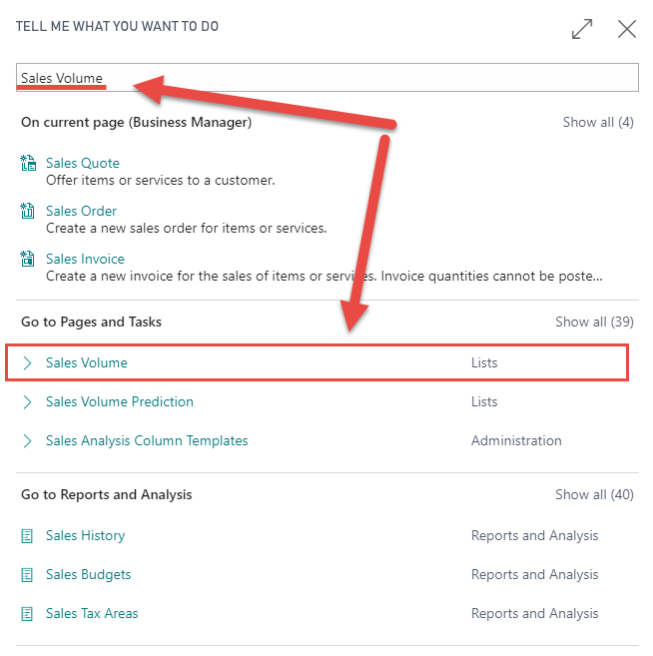

1. In the Sales Volume page, click **Actions > Import data…**
2. In the **Import** dialog, click **Choose…**
3. Locate and select the **Sales Volume.csv** file, and then click **Open**. The Sales Volume page populates with data:

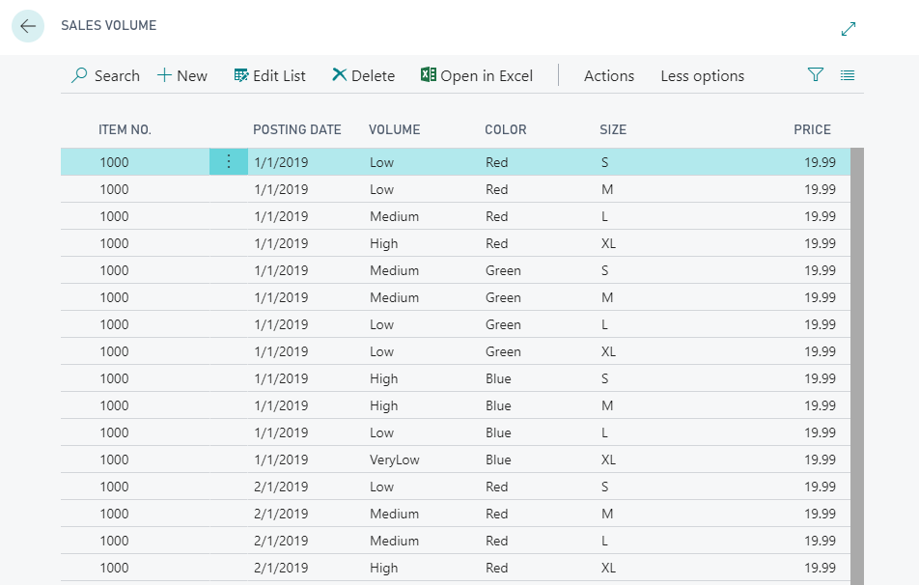

1. Click **Actions > Train Model**.
2. If everything is correctly set up, after a few seconds a message will tell you that the model is trained and inform you about the model quality:

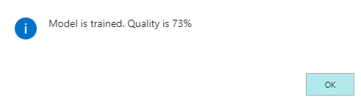

1. Click **OK**.
2. In the **Tell me** box, search for and run **Sales Volume Prediction**.

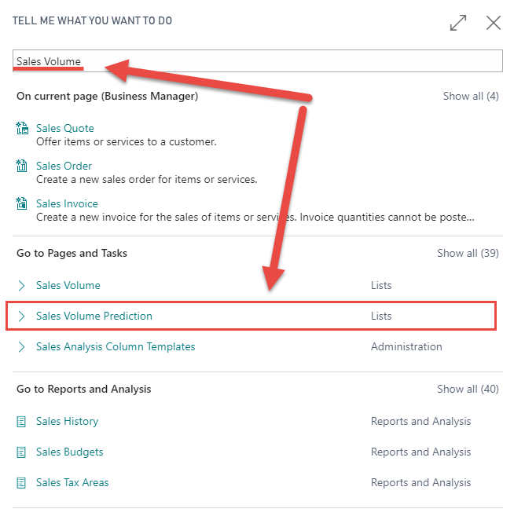

1. In the **Sales Volume Prediction** page, click **Edit List**.
2. Populate the table as follows:

|  |  |  |
| --- | --- | --- |
| Color | Size | Price |
| Red | S | 20.00 |
| Red | M | 20.00 |
| Red | L | 20.00 |
| Red | XL | 20.00 |
| Red | S | 30.00 |
| Red | M | 30.00 |
| Red | L | 30.00 |
| Red | XL | 30.00 |

You can leave other fields empty. Item No. and Posting Date play no role in prediction.

1. Click **Actions > Predict**.
2. After a few seconds, the codeunit you invoked will populate the predictions from the machine learning web service. The **Volume** column will indicate the expected sales volume, and the **Confidence** column will indicate how confident the model is in its prediction. Any values lower than the calculated model quality will be shown in red.

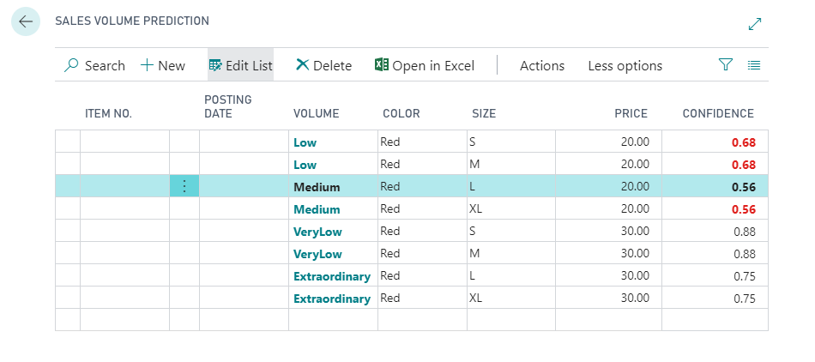

# Challenge Yourself: Titanic Survival Prediction

In this exercise you will train a classification prediction model with Titanic passenger data set. Titanic survival prediction is a “Hello, World!” of machine learning, and is often used to test prediction algorithms.

Your task is to create the necessary objects to import Titanic dataset, import the dataset, train the prediction model, and finally test the model by providing random passenger data, and verify whether those hypothetical passengers would survive or perish on Titanic.

## Extend the setup

1. Modify table 50130 **Classification Setup**, and add the following new fields:

|  |  |  |
| --- | --- | --- |
| ID | Field | Type |
| 6 | Titanic Prediction Model | Blob |
| 7 | Titanic Predict. Model Quality | Decimal  The field must not be editable. |

1. Copy the GetModel and SetModel functions, and rename them to GetTitanicModel and SetTitanicModel, respectively.
2. Inside these two functions, modify field references to use **Titanic Prediction Model** instead of **Sales Volume Model**.
3. Modify page 50130 **Classification Setup**:
   1. Inside the **Models** group, and after the **Sales Volume Model** subgroup, create a new group named **Titanic Prediction Model**.
   2. In this group, add the two additional fields that you have added to the **Classification Setup** table in the previous step.

## Create the data model

1. Create a new file and name it “Table 50133 Titanic Passenger.al”.
2. In the file, declare table 50133 "Titanic Passenger" with the following fields:

|  |  |  |
| --- | --- | --- |
| ID | Field | Type |
| 1 | Id | Integer  AutoIncrement = true |
| 2 | Name | Text[250] |
| 3 | Class | Option  OptionMembers: 1st, 2nd, 3rd |
| 4 | Age | Integer  BlankZero = true |
| 5 | Age is Known | Boolean |
| 6 | Sex | Option  OptionMembers: Male, Female |
| 7 | Survived | Boolean |
| 8 | Confidence | Decimal  BlankZero = true  Editable = false |

1. Declare the keys section and in it declare the primary key field over the Id column. Make the primary key clustered.
2. For the **Age** field, define the OnValidate trigger. From the trigger, set the **Age is Known** field depending on the value entered in the **Age** field. Age is deemed unknown if it is 0.
3. For the **Age is Known** field, define the OnValidate trigger. From the trigger, if **Age** is higher than 0, and **Age is Known** is false, set **Age** to 0. Also, if Age is equal to 0, and **Age is Known** is true, set **Age is Known** to false.

### Solution: Table 50133 Titanic Passenger.al

table 50133 "Titanic Passenger"

{

Caption = 'Titanic Passenger';

fields

{

field(1; Id; Integer)

{

Caption = 'Id';

AutoIncrement = true;

}

field(2; Name; Text[250])

{

Caption = 'Name';

}

field(3; Class; Option)

{

Caption = 'Class';

OptionMembers = "1st","2nd","3rd";

OptionCaption = '1st,2nd,3rd';

}

field(4; Age; Integer)

{

Caption = 'Age';

BlankZero = true;

trigger OnValidate();

begin

"Age is Known" := Age > 0;

end;

}

field(5; "Age is Known"; Boolean)

{

Caption = 'Age is Known';

trigger OnValidate();

begin

if (Age > 0) and (not "Age is Known") then

Age := 0;

if (Age = 0) and "Age is Known" then

"Age is Known" := false;

end;

}

field(6; Sex; Option)

{

Caption = 'Sex';

OptionMembers = Male,Female;

OptionCaption = 'Male,Female';

}

field(7; Survived; Boolean)

{

Caption = 'Survived';

}

field(8; Confidence; Decimal)

{

Caption = 'Confidence';

BlankZero = true;

Editable = false;

}

}

keys

{

key(Primary; Id) { Clustered = true; }

}

}

## Create the XmlPort

1. Create a new file and name it XmlPort 50133 Import Titanic Passengers.al.
2. Inside the file declare xmlport 50133 "Import Titanic Passengers" with the following specification:
   1. It uses VariableText format.
   2. It uses “;” as its field separator.
   3. It supports only import direction.
3. It contains schema with one root text element, that contains one table element that will contain fields from the **Titanic Passenger** table.
4. Inside the table element, declare the following fields
   1. Name, maps to “Titanic Passenger”.Name
   2. Class, maps to “Titanic Passenger”.Class
   3. Age, a text element (variable), does not map directly to a field
   4. Sex, maps to “Titanic Pasenger”.Sex
   5. Survived, maps to “Titanic Passenger”.Survived
5. For the **Age** text element, define the OnAfterAssignVariable trigger. In the trigger, set the **Age** field on the **Titanic Passenger** record to 0 and set the **Age is Known** field to false. Then, if the **Age** variable is not blank, evaluate its content into the **Age** field, and set the **Age is Known** field to true.

### Solution: XmlPort 50133 Import Titanic Passengers.al

xmlport 50133 "Import Titanic Passengers"

{

Format = VariableText;

FieldSeparator = ';';

Direction = Import;

schema

{

textelement(root)

{

tableelement(TitanicPassenger; "Titanic Passenger")

{

fieldelement(Name; TitanicPassenger.Name) { }

fieldelement(Class; TitanicPassenger.Class) { }

textelement(Age)

{

trigger OnAfterAssignVariable();

begin

TitanicPassenger.Age := 0;

TitanicPassenger."Age is Known" := false;

if Age <> '' then begin

Evaluate(TitanicPassenger.Age, Age);

TitanicPassenger."Age is Known" := true;

end;

end;

}

fieldelement(Sex; TitanicPassenger.Sex) { }

fieldelement(Survived; TitanicPassenger.Survived) { }

}

}

}

}

## Create the codeunit stub

1. Create a new file and name it Codeunit 50133 Titanic Passenger Pred. Mgt.al.
2. In the file, declare codeunit 50133 "Titanic Passenger Pred. Mgt.".
3. Declare two public functions:
   1. Function **Train**, receives no parameters and returns no value.
   2. Function **Predict**, receives a by-reference temporary **Titanic Passenger** record as a parameter, and returns no value.
4. Do not put any code yet into these functions.

## Create the list page

1. Create a new file and name it Page 50133 Titanic Passengers.al.
2. Inside the file, declare page 50133 "Titanic Passengers". It must be a page of type list over the **Titanic Passenger** source table. Define **UsageCategory** of **Lists** and set the **ApplicationArea** to **All**.
3. Declare the layout section.
4. Inside the layout section, declare the Content area.
5. Inside the Content area, declare a repeater, and name it **Passengers**.
6. Inside the **Passengers** repeater, add all the fields from the **Titanic Passenger** table, except for fields **Id** and **Confidence**.
7. Define the actions section with Processing area.
8. Define the **Import** action with the following logic:
   1. Empty the **Titanic Passenger** table.
   2. Run the **Import Titanic Passengers** XMLport.
9. Define the **Train** action that invokes the **Train** function from the **Titanic Passenger Pred. Mgt.** codeunit.

### Solution: Page 50133 Titanic Passengers.al

page 50133 "Titanic Passengers"

{

Caption = 'Titanic Passengers';

PageType = List;

SourceTable = "Titanic Passenger";

UsageCategory = Lists;

ApplicationArea = All;

layout

{

area(Content)

{

repeater(Passengers)

{

field(Name; Name) { ApplicationArea = All; }

field(Class; Class) { ApplicationArea = All; }

field(Age; Age) { ApplicationArea = All; }

field("Age is Known"; "Age is Known") { ApplicationArea = All; }

field(Sex; Sex) { ApplicationArea = All; }

field(Survived; Survived) { ApplicationArea = All; }

}

}

}

actions

{

area(Processing)

{

action(Import)

{

Caption = 'Import';

Ellipsis = true;

Image = ImportExcel;

ApplicationArea = All;

trigger OnAction();

var

TitanicPassenger: Record "Titanic Passenger";

begin

TitanicPassenger.DeleteAll();

Xmlport.Run(Xmlport::"Import Titanic Passengers", false, true);

end;

}

action(Train)

{

Caption = 'Train Model';

Image = CalculatePlan;

ApplicationArea = All;

trigger OnAction();

var

Prediction: Codeunit "Titanic Passenger Pred. Mgt.";

begin

Prediction.Train();

end;

}

}

}

}

## Create the prediction page

1. Create a new file and name it Page 50134 Titanic Prediction.al.
2. In the file, declare page 50134 "Titanic Prediction".
3. Copy the entire content of page 50133 **Titanic Passengers** and paste it into the page **Titanic Prediction**.
4. Set the **SourceTableTemporary** page property to true.
5. Make the **Survived** field not editable.
6. Add the **Confidence** field after the **Survived** field. Make it not editable.
7. Modify the **Predict** action. Make it invoke the Predict method of the **Titanic Passenger Pred. Mgt.** codeunit.
8. Rename the **EntryNo** global variable to **NextId**.
9. Remove the **MinimumConfidence** global variable.
10. Modify the definition of the OnOpenPage trigger:
    1. Remove the assignment of the **MinimumConfidence** variable.
    2. Modify the TestField line by replacing the **Sales Volume Model** with **Titanic Prediction Model**.

### Solution: Page 50134 Titanic Prediction.al

page 50134 "Titanic Prediction"

{

Caption = 'Titanic Prediction';

PageType = List;

SourceTable = "Titanic Passenger";

SourceTableTemporary = true;

UsageCategory = Lists;

ApplicationArea = All;

layout

{

area(Content)

{

repeater(Passengers)

{

field(Name; Name) { ApplicationArea = All; }

field(Class; Class) { ApplicationArea = All; }

field(Age; Age) { ApplicationArea = All; }

field("Age is Known"; "Age is Known") { ApplicationArea = All; }

field(Sex; Sex) { ApplicationArea = All; }

field(Survived; Survived)

{

Editable = false;

ApplicationArea = All;

}

field(Confidence; Confidence)

{

Editable = false;

ApplicationArea = All;

}

}

}

}

actions

{

area(Processing)

{

action(Predict)

{

Caption = 'Predict';

Image = CalculatePlan;

ApplicationArea = All;

trigger OnAction();

var

Prediction: Codeunit "Titanic Passenger Pred. Mgt.";

begin

Prediction.Predict(Rec);

end;

}

}

}

var

NextId: Integer;

trigger OnNewRecord(BelowxRec: Boolean);

begin

NextId += 1;

Id := NextId;

end;

trigger OnOpenPage();

var

Setup: Record "Classification Setup";

begin

Setup.Get();

Setup.TestField("Titanic Prediction Model");

end;

}

## Final challenge: business logic

Your task here is to complete the business logic in the **Titanic Passenger Pred. Mgt.** codeunit. Use the **Sales Volume Classif. Mgt.** codeunit as your template.

Try not to consult the solution code, unless absolutely necessary.

After you have modified the business logic, run your extension, import the Titanic dataset, train the model, enter data for a few hypothetical passengers, and then run the prediction.

### Solution: Codeunit 50133 Titanic Passenger Pred. Mgt.al

codeunit 50133 "Titanic Passenger Pred. Mgt."

{

local procedure GetSetup(var Setup: Record "Classification Setup");

begin

Setup.Get();

Setup.TestField("API URI");

Setup.TestField("API Key");

end;

procedure Train();

var

Setup: Record "Classification Setup";

TitanicPassenger: Record "Titanic Passenger";

Prediction: Codeunit "ML Prediction Management";

Model: Text;

ModelQuality: Decimal;

begin

GetSetup(Setup);

Prediction.Initialize(Setup."API URI", Setup."API Key", 0);

Prediction.SetRecord(TitanicPassenger);

Prediction.AddFeature(TitanicPassenger.FieldNo(Class));

Prediction.AddFeature(TitanicPassenger.FieldNo(Age));

Prediction.AddFeature(TitanicPassenger.FieldNo("Age is Known"));

Prediction.AddFeature(TitanicPassenger.FieldNo(Sex));

Prediction.SetLabel(TitanicPassenger.FieldNo(Survived));

Prediction.Train(Model, ModelQuality);

Setup.SetTitanicModel(Model);

Setup."Titanic Predict. Model Quality" := ModelQuality;

Setup.Modify(true);

Message('Model is trained. Quality is %1%',

Round(ModelQuality * 100, 1));

end;

procedure Predict(var TitanicPassenger: Record "Titanic Passenger" temporary);

var

Setup: Record "Classification Setup";

Prediction: Codeunit "ML Prediction Management";

begin

GetSetup(Setup);

Setup.TestField("Titanic Prediction Model");

Prediction.Initialize(Setup."API URI", Setup."API Key", 0);

Prediction.SetRecord(TitanicPassenger);

Prediction.AddFeature(TitanicPassenger.FieldNo(Class));

Prediction.AddFeature(TitanicPassenger.FieldNo(Age));

Prediction.AddFeature(TitanicPassenger.FieldNo("Age is Known"));

Prediction.AddFeature(TitanicPassenger.FieldNo(Sex));

Prediction.SetConfidence(TitanicPassenger.FieldNo(Confidence));

Prediction.SetLabel(TitanicPassenger.FieldNo(Survived));

Prediction.Predict(Setup.GetTitanicModel());

end;

}